Building an Effective EMERGENCY EVACUATION PLAN for Building Name

Building Name: Stauffer Hall, A wing

Building Number: 24A STAUF

Building Address: 950 S Forest Mall, Tempe, AZ 8528

In the event of a campus emergency, this plan is designed to assist in the safe evacuation of students, faculty, staff, and visitors. This plan establishes the protocols for a safe and orderly evacuation of people due to a hazard that threatens the university such as but not limited to: severe weather event, fire, hazardous material spill, terrorist act, building maintenance issue, etc.

Being prepared to handle unexpected emergencies is both an organizational and individual responsibility. When an emergency happens, the safety of ASU’s Campus Community is dependent upon the level of your preparedness.

Preparedness is often defined by how well you respond to and recover from an incident; be prepared. The first step in preparing for the unforeseen emergency which may cause the entire and/or partial evacuation of a building is to create an Emergency Evacuation Plan. This plan will not only outline the process for a safe evacuation, but assigns responsibilities and communicates the behavioral expectations of the building’s occupants. This plan’s success is dependent on building tenants collaborating to create the overall evacuation plan. Associated tasks assigned to the committee will likely include:
- Assembly of appropriate human and physical resources;
- Creation of the Evacuation Plan;
- Distribution of plan;
- Training of the plan;
- The purchase and maintenance of the emergency evacuation supplies (vests, flashlights, megaphone, etc.);
- The annual revision of the plan.
It is important to understand that at any time, Arizona State University could be subjected to an unexpected emergency. Therefore, there is a need to not only have an Emergency Evacuation Plan but to train on the plan for better preparedness. An Emergency Evacuation Plan makes provisions for the orderly evacuation of all building occupants, to include those with limited mobility or functional needs, by placing life as the highest priority.
Emergency Evacuation Plans are in addition to and support the Emergency Response Guide (ERG) https://cfo.asu.edu/emergency-guide and your department’s Continuity of Operation Plan (COOP). The intent of this plan is to provide a useful tool for your departmental emergency evacuation training, assurance of a safe evacuation for your area or building, certain responsibilities, and specific actions to help conduct an evacuation.

Arizona State University’s Emergency Evacuation Plans should be written for each building using a collaborative approach by building occupants. An Emergency Evacuation Plan is required for your building.

Next Steps:
- Create an Emergency Evacuation Plan development team that includes a representative from each unit/department in your building
- Develop the Emergency Evacuation Plan for your building
  - An Emergency Evacuation Plan template is included; it is intended to provide instructions, guidance, and sample text for the development of the building’s Evacuation Plan. Use of this template is optional and your team may agree to use another style. However, all information contained in the template, must and at a minimum, be included in your building plan.
  - Assign Floor/Fire Wardens
  - Identify Primary and Secondary Assembly areas away from the building
  - Include occupants of your building with disabilities
- Distribute the plan to all building occupants
- Train all building occupants on your plan
- Test the plan – Evacuation Drills
- Include distribution and training of your Emergency Evacuation Plan to all new employees in your unit/department
- Annually review and update your plan accordingly

Contacts for additional assistance if needed:
Accident and Injury Claim Forms | https://cfo.asu.edu/ehs-incident-reporting
ASU Employee Assistance | 480-965-2271
ASU Fire Marshal and Advanced Training | asufire@asu.edu
ASU Police (non-emergencies) | 480-965-3456
Continuity of Operation Planning (COOP) | ASUReady@asu.edu
EHS Safety Trainings | https://cfo.asu.edu/ehs-training
Emergency Response Guide (ERG) | 480-965-1823
Evacuation Drills | asufire@asu.edu
Occupational Health and Safety | https://cfo.asu.edu/ehs-occupationalsafety
ADA Disability Related questions or concerns | 480-727-4501; 480-965-3288; 480-965-0705

Evacuation Plan

Building Name: Stauffer Hall

Building Number: STAUF, A24

Plan Lead (Name and Phone): Ira Ochs / 480-965-6313

Last Updated: 9/4/19

Additional Plan Organizers:
Name | Department | Phone | Email
Misa Pham | Human Communication | (480) 965-4231 | Misa.pham@asu.edu
Suzanne Wurster | Human Communication | (480) 965-2851 | Suzanne.Wurster@asu.edu

EMERGENCY CONTACTS
On Campus Emergencies --------------------- | 911
ASU PD Non-Emergency
Tempe Campus------------------ | 480-965-3456
Polytechnic Campus------------ | 480-727-3456
West Campus-------------------- | 602-543-3456
Downtown Campus------------- | 602-496-3456

Building Occupant Responsibilities:

An effective response and subsequent evacuation requires the cooperation of all occupants in a building. Building occupants, to include visitors must know how to act. This section outlines specific responsibilities for employees, faculty, and staff and visitors.

- Become familiar with the building and the safety devices (pull stations, fire extinguishers, fire alarm, fire suppression systems, ADA areas, egress components, AEDs, etc.);
- Know the building’s evacuation routes and assembly area’s;
- Participate in drills and training;
- Orient students with a brief overview of emergency evacuation procedures on the first day of class;
- Assist visitors evacuate safely.

Floor or Fire Warden:

Floor or Fire Wardens are common terms used for designated staff position(s) that are responsible for assisting others in the orderly management of an evacuation. These positions should be filled by trained personnel familiar with the emergency plans, design of the building, and evacuation assembly areas. Each primary floor or fire warden position should have an alternate that can function in their absence. Primaries and alternates can be volunteers or occupants of the building appointed by management within the department. Floor and fire wardens may receive special training and will work with the ASU Office of the Fire Marshal related to annual testing.

Duties of the Floor or Warden

- If safe to do so, conduct a quick search of your responsible area. Close doors behind you.

- Give instructions to students or visitors that may not be familiar with the building regarding the best evacuation routes.

- Try to keep occupants calm while directing them to the nearest, yet safest exit. Remind them to go to the assembly areas so they can be accounted for.

- Close all stairway and exits doors; never block them open or closed.

- Special attention should be given to anyone with functional needs.

Floor/Fire Wardens

Floor | Name | Phone # | Email | Schedule (M-F 8-5)
1st | Barbara DeDecker | 480-965-5707 | Barbara.dedecker@asu.edu | M-F 8-5
2nd | Alison Trego | 480-965-5095 | Alison.trego@asu.edu | Alternates w teaching schedule
2nd | Janet Jacobsen | 480-965-5095 | Janet.jacobsen@asu.edu | Alternates w teaching schedule
3rd | Jennifer Linde | 480-727-6763 | jlinde@asu.edu | Alternates w teaching schedule
4th | Suzanne Wurster | 480-965-2851 | Suzanne.wurster@asu.edu | M-F 7-4:30
4th | Ira Ochs | 480-965-6313 | Ira.Ochs@asu.edu | M-F 8-5

Evacuation Procedure

- When an alarm sounds, begin immediate evacuation.
- Close doors behind you.
- If you discover a fire or smoke, and the alarm has not sounded, activate the nearest pull station and call 9-1-1.
- If the fire alarm does not work, call 9-1-1 and notify occupants verbally of the emergency and the need to evacuate.
Do Not Use The Elevators!
When the alarm sounds, the elevators may automatically recall to a pre-determined floor and shut down.

- If trained and safe to do so, you may attempt to extinguish small fires (no larger than a wastebasket).
- If the fire is too large or you are uncomfortable or unfamiliar with the proper use of a fire extinguisher, close the door and evacuate.
- In all cases, dial 9-1-1 and advise them of your actions.

Hazardous equipment and processes should be shut down unless doing so presents a greater hazard. Close doors upon leaving area.

- Evacuate to the nearest and safest exit. Keep doors closed to help slow the spread of smoke and fire.

- Person(s) with functional needs, refer to the Emergency Evacuation for Persons with Disabilities section for additional evacuation options.

- Evacuate to the pre-determined Evacuation Assembly Point (EAP) (as determined by the department or building committee). You may have two or more EAP’s depending on the size of the building. Once assembled, immediately report to your designated floor or fire warden for accountability.

- Evacuation note: only take items of extreme importance from your work space and only take those items if they can be removed safely (i.e. car and house keys, medication, and wallets/ purses). Do not remove large or bulky items, photographs, etc.

- Refer to your Emergency Response Guide (ERG) for more details related to fire/evacuation and other emergency scenarios.

Primary and alternate Assembly Points (describe the location and/or attach a map showing the areas)
Assembly points are locations where building staff can assemble and be accounted for. In addition, information related to the incident can be shared with building occupants from these locations. Assembly points should be walking distance from the building but not too close. If they are located too close, first responders will likely move you from your assembly area in order to establish a perimeter around the incident. If possible, other building can be used to “shield” you from the affected areas. Large areas of grass are often good choices as temperatures tend to be cooler and the ground is softer than concrete.
Primary Evacuation Area:
The Primary Assembly Area for Stauffer Communication Arts A Wing is located under the covered portion of the east side of Coor Hall extending out onto Forest Mall.
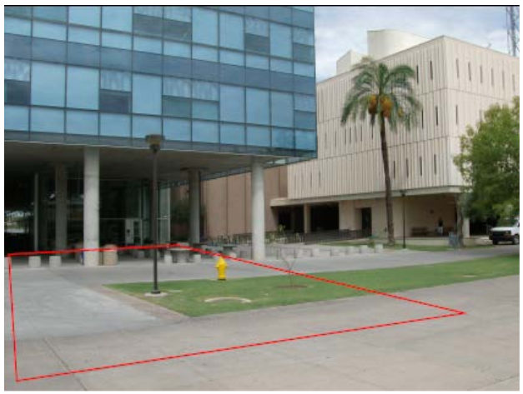

Alternate Evacuation Area:
The Secondary Assembly Area for Stauffer Communication Arts, (HDSHC) is located in the open area between the Stauffer buildings and the Art Building on the north side.
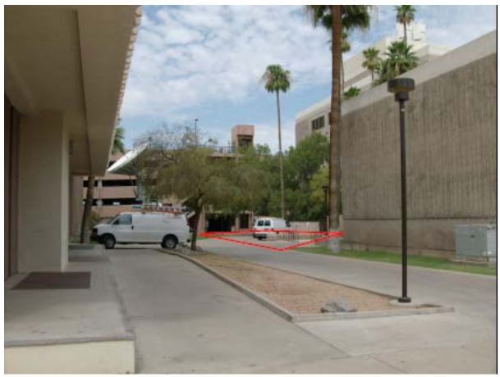

Re-entry procedure

Never re-enter a building after evacuating unless cleared by emergency personnel!

Once it is determined that re-entry can be made, emergency personnel will give an “All Clear”. Note: Emergency personnel are the police, fire department, and Environmental Health & Safety (EH&S). The building may require evaluation or monitoring to confirm no exposures remain before returning to the building, this is usually performed by EH&S or their contracted services.

Emergency Evacuation for Persons with Disabilities
This section provides a general guideline of evacuation procedures for persons with disabilities. It is likely they may require additional assistance or guidance during an evacuation. It is important to note that the person assisting should never do more than what is being asked by the person in need. Faculty, staff, students and visitors with functional needs should be included in the development of this plan in order to customize their primary and secondary evacuation routes.
Prior planning and practicing of emergency evacuation routes are important in assuring a safe evacuation.
Mobility Impaired – Wheelchair: Persons using wheelchairs should stay in place, or move to an area for refuge when the alarm sounds. If the person with a disability is alone, he/she should phone emergency services at 9-1-1 with their present location and the area they are headed too for refuge.
Mobility Impaired - Non-Wheelchair: Persons with mobility impairments, who are able to walk independently, may be able to negotiate stairs in an emergency with minor assistance. If danger is imminent, the individual may wait until the heavy traffic has cleared before attempting the stairs. If there is no immediate danger (detectable smoke, fire, or unusual odor), the person with a disability may choose to stay in the building, using other options listed below, until the emergency personnel arrive and determine if evacuation is necessary.
Hearing Impaired: Most buildings on campus are equipped with fire alarm strobe light to facilitate an alarm warning for the hearing impaired. Reasonable accommodations for persons with hearing impairments may be met by modifying the building fire alarm system, particularly for occupants who spend most of their day in one location.
Visually Impaired: Most people with a visual impairment will be familiar with their immediate surroundings and frequently traveled routes. Since the emergency evacuation route may be different from the commonly traveled route, persons who are visually impaired may need assistance in evacuating. The assistant should offer their elbow to the individual with a visual impairment and guide them through the evacuation route. During the evacuation the assistant should communicate as necessary to assure safe evacuation.
Persons with disabilities have four basic evacuation options:
Horizontal evacuation: Exit one building to another by using an exit passageway or go directly to the outside safely at ground level.

Stairway evacuation: Above ground level, remain in the stairway enclosure and let others evacuating know you will remain there and to tell the fire department of your location (Stairway enclosures are a separate fire rated building within a building).

Stay in Place: Unless you are in imminent danger, it may be safest to remain in a room that has an exterior window, telephone, and a door that closes. With this approach, the person may keep in contact with emergency services by dialing 9-1-1 and reporting their location directly. Emergency services will immediately relay this location to on-site emergency personnel, who will determine the necessity for evacuation. The Stay in Place approach may be more appropriate for sprinkler protected buildings.

Usually, the safest areas for refuge are stairway enclosures. Additional areas may include: fire rated corridors or vestibules adjacent to exit stairs and elevator lobbies. Many campus buildings feature fire rated corridor construction that may offer safe refuge. Taking a position in a rated corridor next to the stair is a good alternative to a small stair landing crowded with the other building occupants.

